What is Git

Git is a free and open-source version control system designed to handle everything from small to very large projects with speed and efficiency.

Git is a distributed version control system for **tracking changes in source code** during software development. It is designed for coordinating work among programmers, but it can be used to track change.

Git has the functionality, performance, security and flexibility that most teams and individual developers need. Git is the most broadly adopted tool of its kind. This makes Git attractive for the following reasons. Vast numbers of developers already have Git experience and a significant proportion of college graduates may have experience with only Git.

Git is an example of version control. Version control is a system that records changes to a file or set of files over time so that you can recall specific versions later.

It allows you to:

* Revert files to previous state,
* Revert entire project back to previous state,
* Compare changes over time,
* See who modified what? **And much more...**

It means if you screw things up or lose files, you can easily recover.

Use cases:

* Individual development,
* Collaborative development,
* Offline usage.

Why Git?

* Everything is local (full history tree available offline),
* Everything is fast and modern,
* Snapshots, not diffs,
* Git provides a history of content changes
* Git facilitates colloborative changes to files.
* It is distributed not centralized,
* Git is easy to us efor any type of knowledge worker.
* Great for those who hate: CVS/SVN (earlier [version control systems](https://lms.clarusway.com/mod/lesson/view.php?id=642)).

Git: Version Control, VCS, Distributed, brings everybody on the same page. track the code, free and open source, Time travel, history of the files. compare changes in social environment

Repo: where our code/files lives

GitHub is a Git repository hosting (Source Code Hosting) service , but it adds many of its own features. It is a web-based platform used for version control and it provides a Web-based graphical interface. It also provides access control and several collaboration features, such as a wikis and basic task management tools for every project.

Like GitHub, there are other source code hosting platforms but GitHub is the most popular one.

**What is the difference between Git and GitHub?**

Git is a version control system that lets you manage and keep track of your source code history locally. GitHub is a cloud-based hosting service that lets you manage Git repositories.

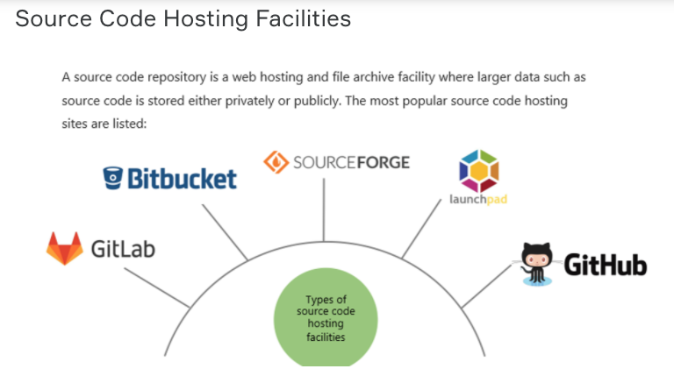

This is a nice graph which shows the most important features of the hosting sites

